**DEPLOY AN ANGULAR 5 APP ON PRODUCTION**

**REF:**

<https://angular.io/guide/deployment>

FIRST STOP NG SERVE COMMAND FROM THE CONSOLE:

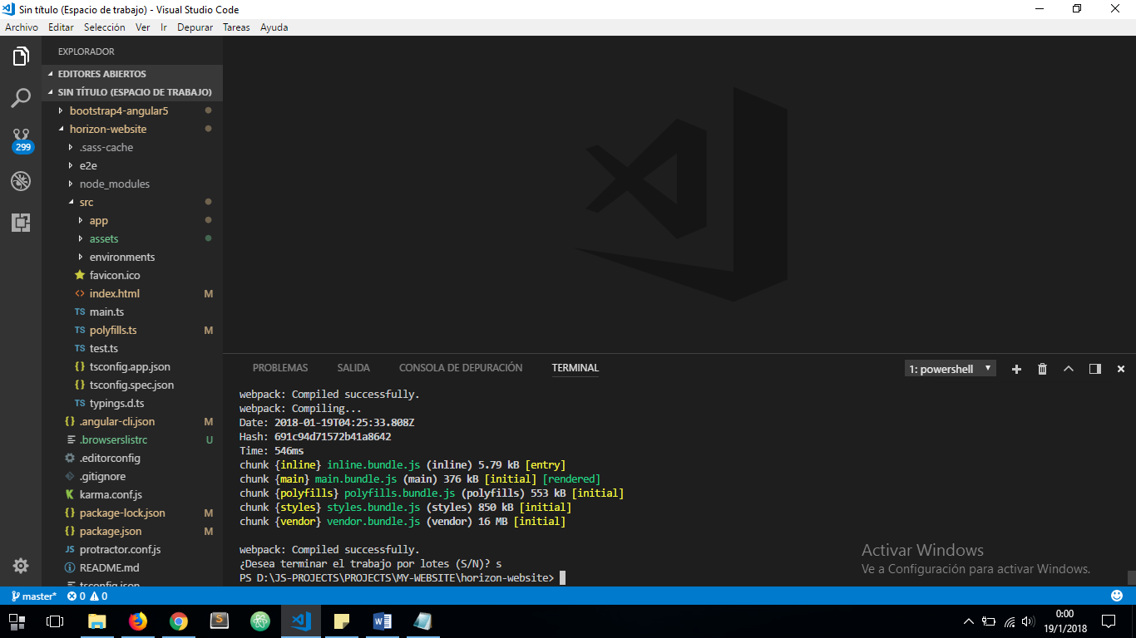

THEN RUN NEXT COMMAND, ENABLING PROD MODE, OPTIMIZING BUNDLE SIZE AND ENABLING PROD ENVIRONMENT AND SPECIFYING THE BASE-HREF PATH: ***ng build --prod --build-optimizer --environment=prod --base-href=/horizon-ts/***

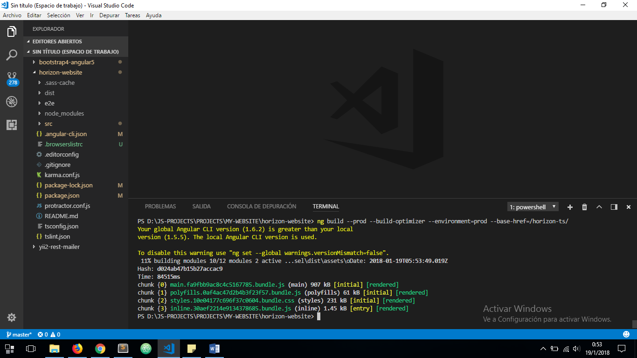

THIS PROCESS COULD TAKE A COPLE OF MINUTES

WHEN PROCESS FINISHES A ***dist*** FOLDER WILL BE CREATED:

